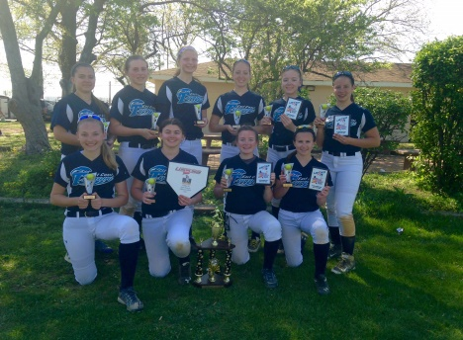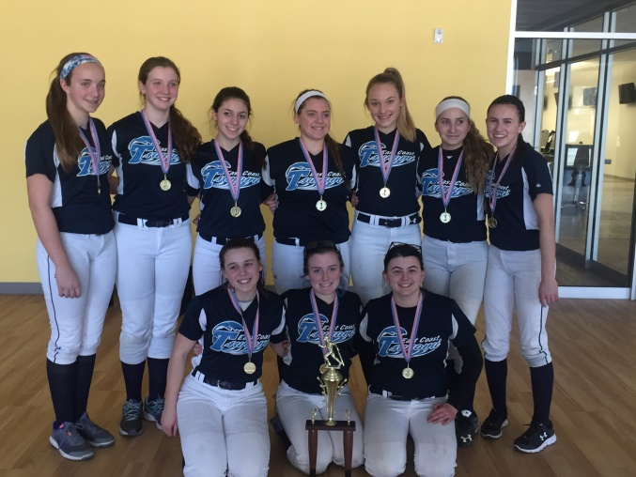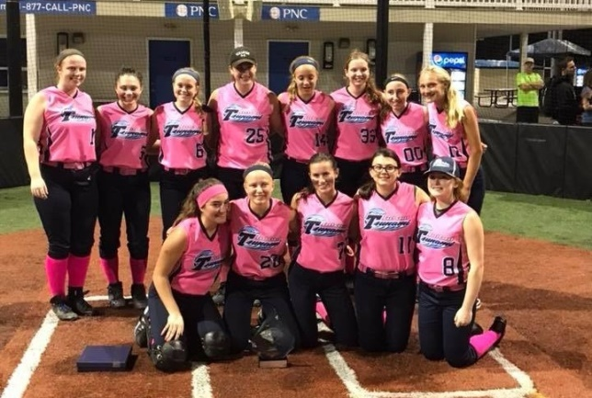

*Tsunami USSSA Champions*

*Tsunami PONY 18U 2017 Champions*

***Thoughts on*** [***Attitude***](http://softball-quotes.blogspot.com/2011/10/attitude.html)***!***   
No matter how good your softball skills are...they won't take you as far as your capable unless you have a TEAM 1st attitude.

Winning is all about attitude, and its attitude that separates true champions from others!

We will be a combination of a winning attitude and unrelenting pursuit of personal improvement with the greater goal of supporting each other and not tearing them down –Ray Romano

# Information

# *18U Gold*

**Ray Romano**

**President | East Coast Tsunami**

[rromano@myldi.com](mailto:rromano@myldi.com)

**(917) 642-8673 (Cell)**

*18U Gold 2017 Jenny Finch Invitational Champions*

*18U Champions*

|  |  |  |
| --- | --- | --- |
| **Month** | **Name of Event** | **Location** |
| **February 18th** | **Spooky Nook Gold Classic** | **Manheim PA** |
| **June 3-5** | **Blue Chip Gold Super 40 Invitational** | **Shamung NJ** |
|  |
| **June 10-12** | **Outlaws East Coast Gold Showdown Invitational** | **Voorhees NJ** |
|  |
| **June 21-24** | **Team NJ / Rock Gold Challenge** | **Newtown PA** |
|  |
| **June** | **TNT Gold Showcase** | **Quakertown PA** |
| **28th – 30th** |
| **July 1st** | **Top Gun Rally for Raylan** | **Hillsborough NJ** |
| **July** | **NE Fusion Gold Summer Showcase** | **Londonderry NH** |
| **6th-8th** |
|  |  |  |
| **July** | **Legends Summer Scorcher** | **Virginia Beach** |
| **12th-15th** | **VA** |
| **July** | **NE Finest Summer Showcase** | **Plainville** |
| **26th-30th** | **MA** |

**2017 -2018  
*East Coast Tsunami***

***18U GOLD - ROMANO***

***www.tsunami-softball.com***

***www.tsunami-softball.com***

2017 – 2018 East Coast Tsunami 18U Gold

******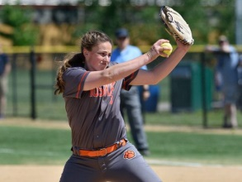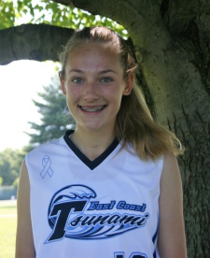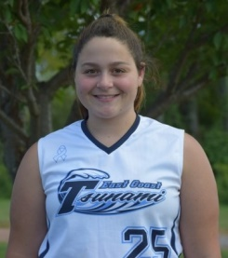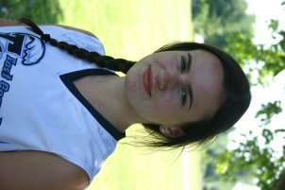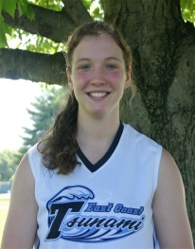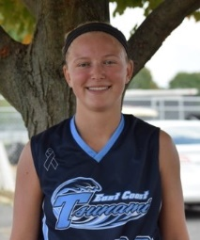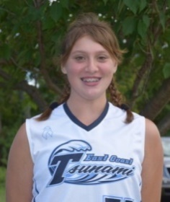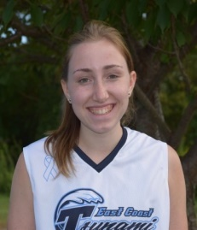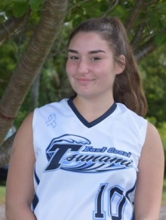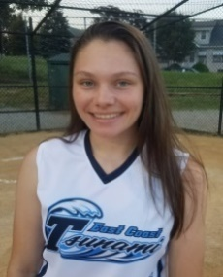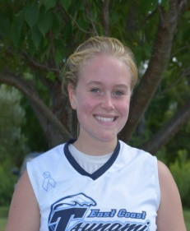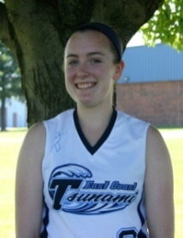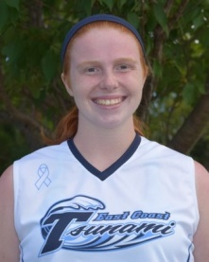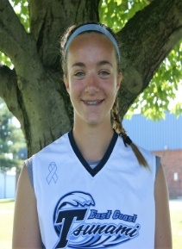

**Erika Mack 8**

***Class of 2020***

***MCVT- HS***

***2x Varsity Letter***

***Position: 3B / SS /***

***“FEARLESS & POWERFUL”***

**Marli Welter 33**

***Class of 2020***

***Madison - HS***

***“2nd Team All NJAC” 4.1 SAT:***

***Position: CF / LF / 1B***

***“HIGH ACADEMIC TALENT”***

***Bats/Throws: L/L***

**COMMITTED**

**Alexa Stephan 00**

***Class of 2020***

***Columbia-HS***

***Varsity Letter***

***Position: 2B / OF /***

***““TOP HITTING TALENT”***

**Jen Sweeney**

***Class of 2017***

***U of Scranton***

***“18U Eligible Events Only “DIV-III ALL-AMERICAN”***

***Bats/Throws: L/L***

**Genna Ricciardi 25**

***Class of 2018***

***Lyndhurst – HS***

***4X Varsity Letter: 4.0 SAT: N/***

***Position: C / 1B / OF***

***“VERSATILE PLAYER”***

**Samantha Romano 7**

***Class of 2021***

***Lenape Valley Regional-HS***

***Varsity Letter***

***Position: CF / 2B***

***“TOP DEFENSIVE TALENT”***

**Gabby Samarelli 5**

***Class of 2019***

***Secaucus – HS***

***3X Varsity Letter: 4.0 SAT: N/***

***Position: SS / 3B /***

***“TOP IMPACT PLAYER”***

**Samantha Perez 10**

***Class of 2020***

***Wood Ridge– HS***

***“2nd Team All Division MVP”***

***Position: Catcher / OF***

***“TOP IMPACT PLAYER”***

**Brenna Dolan 16**

***Class of 2018***

***Cranford-HS***

***4x Varsity Letter***

***Position: Pitcher / 1B***

***“TOP LEADER’***

**Jenna Devens 14**

***Class of 2021***

***Parsippany - HS***

***Varsity Letter***

***Position: P / 1B***

***“TOP PITCHER-HITTER***

**Justyne D’Ascoli 28**

***Class of 2019***

***Sparta - HS***

***3x Varsity Letter***

***Position: SS / 2B***

***‘TOP TALENT’***

**COMMITTED**

**COMMITTED**

**Julia Swan 77**

***Class of 2021***

***Whippany Park –HS***

***Varsity Letter***

***Position: P / 1B***

***““TOP PITCHER”***

**Samantha Hess 12**

***Class of 2020***

***Academy of Holy Angles-HS***

***“2nd Team All Big North”***

***Position: 2B / OF***

***“HIGH ACADEMIC TALENT”***

**Lauren O’Shea 6**

***Class of 2021***

***Becton Regional - HS***

***Varsity Letter***

***Position: P / 1B***

***Bats/Throws: R/R***